**DAILY ONLINE ACTIVITIES SUMMARY**

|  |  |  |  |  |  |  |  |
| --- | --- | --- | --- | --- | --- | --- | --- |
| **Date:** | **24/05/2020** | | | | **Name:** | **Albin Francis** | |
| **Sem & Sec** | **8th- A** | | | | **USN:** | **4AL16CS008** | |
| Online Test Summary | | | | | | | |
| **Subject** | | **------** | | | | | |
| **Max. Marks** | | **------** | | **Score** | | **------** | |
| Certification Course Summary | | | | | | | |
| **Course** | **Getting Started To Hadoop** | | | | | | |
| **Certificate Provider** | | | **GreatLearning** | **Duration** | | | **5.5hr** |
| Coding Challenges | | | | | | | |
| **Problem Statement:**   1. **Python Program to read the number and compute the series.** 2. **Python program to count number of digits in it.** | | | | | | | |
| **Status: Executed** | | | | | | | |
| **Uploaded the report in Github** | | | | **Yes** | | | |
| **If yes Repository name** | | | | **albinfrancis008** | | | |
| **Uploaded the report in slack** | | | | **Yes** | | | |

# Online Test Details: -

Certification Course Details:

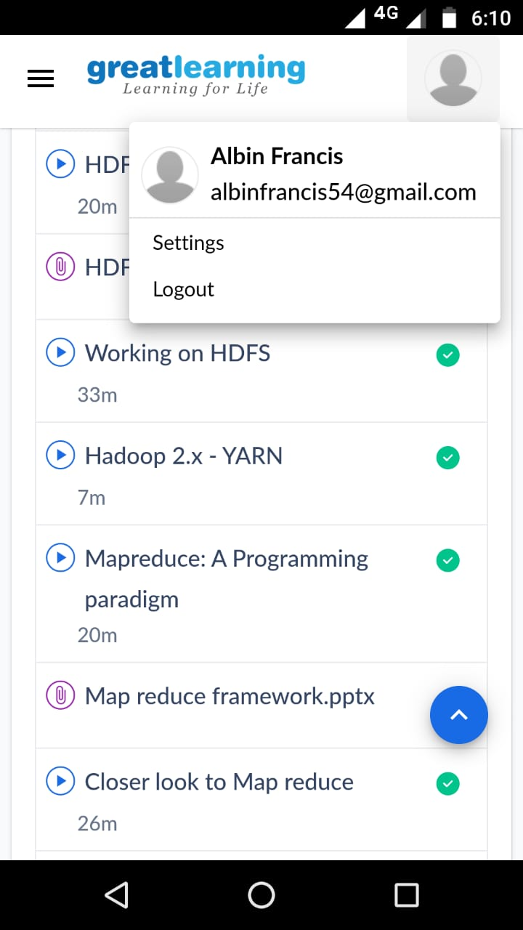

CLOSER LOOK TO MAPREDUCE:-

* Discussed an example anagram in map reduce.
* four fundamental transformations data is:

1. Transformed from the input files and fed into the mappers
2. Transformed by the mappers
3. Sorted, merged, and presented to the reducer
4. Transform by reducers and written to output files

* A job is divided into multiple tasks which are then run onto multiple data nodes in a cluster.
* It is the responsibility of job tracker to coordinate the activity by scheduling tasks to run on different data nodes.
* Execution of individual task is then to look after by task tracker, which resides on every data node executing part of the job.
* Task tracker's responsibility is to send the progress report to the job tracker.
* In addition, task tracker periodically sends heartbeat signal to the Jobtracker so as to notify him of the current state of the system.
* Thus job tracker keeps track of the overall progress of each job. In the event of task failure, the job tracker can reschedule it on a different task tracker.

Coding Challenges Details:

**1) Python Program to read the number and compute the series.**

n=int(input("Enter a number: ")) a=[]

for i in range(1,n+1): print(i,sep=" ",end=" ") if(i<n):

print("+",sep=" ",end=" ") a.append(i)

print("=",sum(a)) print()

2) **Python program to count number of digits in it.**

n=int(input("Enter number:")) count=0

while(n>0):

count=count+1 n=n//10

print("The number of digits in the number are:",count)